CPSC 58100 Vibe Coding – Lab 5
Josh Brown
Tool Used: Claude

Part 1 –
Initial Prompts for establishing project architecture:
As a senior architect engineer and web developer, propose a project structure for an application that allows users to track their vinyl record and CD collections. Use React for the frontend and Node.js for the backend. Provide a folder hierarchy that separates concerns, dependencies and ensures that files and code will be easily understood, readable, and maintainable. Do not generate any code yet.

Great! Again, without generating any code, provide a brief list of the most important dependencies needed for this project. Let's use MongoDB for the database, Express and Node.js, and React. Categorize the dependencies based on frontend, backend, and shared.
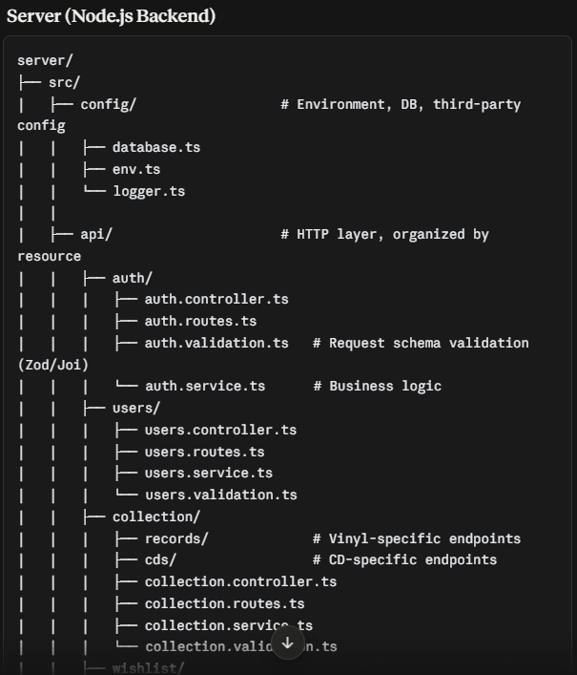
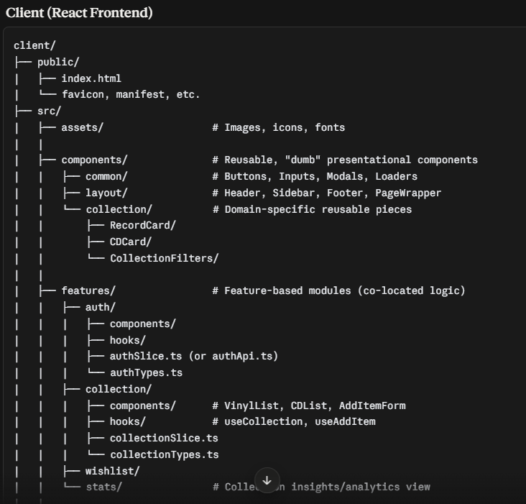
Claude’s recommended file structure:

Claude’s recommended dependencies:
Frontend  React/react-dom  React-router-dom  Axios  React-hook-form  Typescript  Vite  tailwindcss | Backend  Express  Mongoose  Typescript  Jswonwebtoken  Bcrypt  Cors  dotenv | Shared  Typescript  Zod

Part 2 –
First prompt for landing page/app entry point:
First, let's focus on just the frontend, so do not generate any code related to the backend. Create a simple landing page for this project using the aforementioned stack, dependencies, and file structure. Again, this initial webpage should be a shell with the just the essentials. The styling of the page should be minimalistic. Use colors like black or a dark metallic gray for the primary color and neon colors like pink, blue and green for accents. The font should be sleek and vintage to fit the vintage or nostalgic theme of vinyl records.

Second prompt for collection page:
Great, now let's add a second page for the actual collection tracker. This page should use the same colors, font, and other themes as the landing page. Again, avoid generating any code for the backend. However, let’s use React components to create a modular and reusable method of displaying data for the future. For now, the only components we absolutely need are album cards for displaying album information, a way to sort saved albums by title, artist, etc., and a search bar that allows users to find and add albums to their collection. Remember not to add any backend code yet.

Third prompt for collection page album card layout:
Let’s add one last component to the collection page. Add a feature that allows users to change how the album cards are laid out. In the grid view, users can view all of the information about the album, including the cover art. In the list view, the information is limited to just the album title, artist, release year, and format (cd or vinyl). As usual, do not generate any code for the backend.

Upon reviewing the implementation that Claude generated, the biggest concern would likely be the use of sample data for albums. Because I specifically asked the AI not to implement any backend code yet, it included two collections containing sample data. Obviously, we don’t want the search bar to use or have hard wired data. This will need to be addressed once the backend is implemented. Among some other issues I noticed with accessibility tags for screen readers, I asked Claude to analyze the files and make notes of any issues related to tightly coupled components, mixing of concerns, or accessibility. It provided a detailed list and explanations as to why they could create some issues down the line. Here is how I re-prompted the AI to refactor the code and correct these problems:
Let's go ahead and fix some of these issues. Do not make any changes to the search bar and reaching directly into the data layer. We can fix all of the accessibility issues, the mixing of concerns, and the smaller issues you mentioned. Like the search bar, if any of these issues require us to implement any backend code, do not fix it yet.
Here is a summary of what the AI refactored:
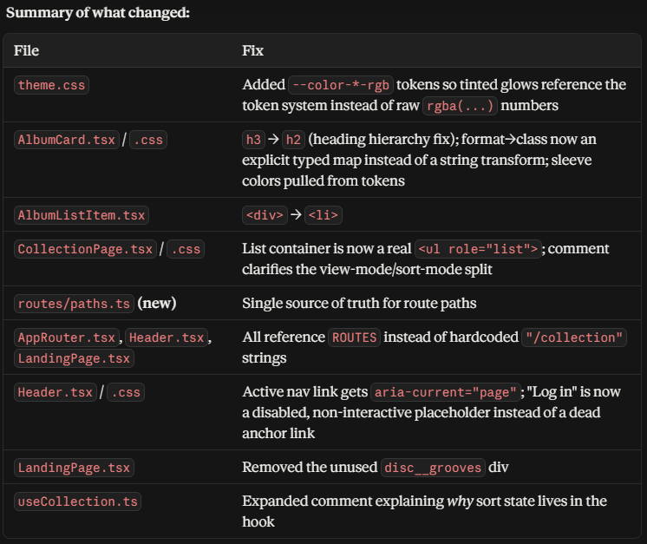
Part 3 –
First backend prompt for MusicBrainz API:
Great! We can now move onto backend. As you are incorporating these changes, be sure to use RESTful endpoints that obey typical response/request behaviors and include meaningful HTTP status codes. We will need an API that pulls album data from music catalogs like MusicBrainz. Don’t worry about the database for now, let’s just focus using real data for our searches. Be sure to follow the backend structure we discussed at the beginning.

Backend prompt to wire up search bar to MusicBrainz API:
Now let's wire up the search bar to the API now and add the outbound rate-limiting so we avoid any issues there.

Add DB

Part 4 –
Make sure there is a source of truth so the frontend and backend agree on structure, naming, and data expectations. Define a formal contract using a shared TypeScript interface, JSON Schema, or equivalent structured definition. Validate that the backend responses and frontend components/services match the contract. Document a bug and explain corrective action.

Part 5 –
Unit test, integration test, E2E test. Use tools such as Vitest, Playwright, Cypress, Jest, or framework specific tools.

Prompt Log
Part 1 –

